BIG DATA PROJECT
<?xml version="1.0"?><DocumentFile xmlns:xsi="http://www.w3.org/2001/XMLSchema-instance" xmlns:xsd="http://www.w3.org/2001/XMLSchema"> <GraphicCharterDefinitionId>0</GraphicCharterDefinitionId> <TemplateBaseTypeId>0</TemplateBaseTypeId> <CompanyId>1</CompanyId> <ConfidentialId>1</ConfidentialId> <ConfidentialDescription>Confidential</ConfidentialDescription> <CountryId>0</CountryId> <PageSizeId>1</PageSizeId> <PageOrientationId>1</PageOrientationId> <PrePrintedStationary>false</PrePrintedStationary> <Project>Project B</Project> <Reference>20150114-160143-LL</Reference> <TemplateType>3</TemplateType> <CultureId>en-GB</CultureId> <LanguageId>1</LanguageId> <Customer>Customer A</Customer> <DocumentDate>2017-07-21T10:21:20.5098702+08:00</DocumentDate> <Saved>false</Saved> <IsValid>true</IsValid> <FirstPageCover>false</FirstPageCover> <IsNew>false</IsNew> <CurrentVersion>1.00</CurrentVersion> <DocumentType>Proposal</DocumentType> <DocumentTypeId>5</DocumentTypeId> <Entity>Entity</Entity> <HasDistributionList>true</HasDistributionList> <HasForeword>false</HasForeword> <Recipient>Recipient Name
Recipient Address</Recipient> <Title>Document Name</Title> <Status>1</Status> <StatusDescription>Preliminary Draft</StatusDescription> <SetEdition>false</SetEdition> <SetVersion>false</SetVersion></DocumentFile>
ENVIRONMENT SETUP

Table of Contents
1. Configure Kafka 3
1.1. Configure Kafka 3
1.2. Unzip Kafka 3
1.3. Start Zoo Keeper 3
1.4. Start Kafka Server 3
1.5. Create Topic 4
1.6. Configure Producer Configuration 4
1.7. Start Yahoo Finance Kafka Producer 5
1.8. Start Spark Stream Kafka Consumer 5
1.9. Delete Kafka log 5
CONFIGURE IMPALA 7
1.10. Create table in Hive 7
1.11. Create view 8
1.12. Validate metdaa 9
1.13. After run validate metadata command, we will see hive table from impala 10
2. CONFIGURE TABLEAU 11

Configure Kafka

Download Kafka from below link

https://kafka.apache.org/downloads

Get Kafka

Configure Kafka

Unzip Kafka

Unzip kafka

tar -xzf kafka_2.13-2.7.0.tgz
$ cd kafka_2.13-2.7.0

Start Zoo Keeper

$ bin/zookeeper-server-start.sh config/zookeeper.properties

Start Kafka Server

Update config/server.properties file as below screenshot

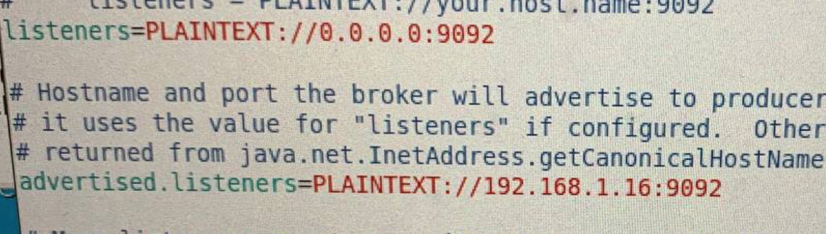

$ bin/kafka-server-start.sh config/server.properties

Create Topic

bin/kafka-topics.sh --create --zookeeper localhost:2181 --replication-factor 1 --partitions 1 --topic livestocks

Configure Producer Configuration
Modify appropriate value for properties in conf.properties file

interval=5000
tickers=JE,UAL,DAL,TNXP,EYES,TRCH,CRON,BCDA,ONCY,URG,HSTO,VEON,ASTC,GNUS,TRIT,AESE,TANH,WPRT
fields=language,region,quoteType,quoteSourceName,triggerable,currency,exchange,shortName,longName,exchangeTimezoneName,exchangeTimezoneShortName,gmtOffSetMilliseconds,market,regularMarketChange,regularMarketChangePercent,regularMarketTime,regularMarketPrice,regularMarketDayHigh,regularMarketDayRange,regularMarketDayLow,regularMarketVolume,regularMarketPreviousClose,regularMarketOpen,averageDailyVolume3Month,averageDailyVolume10Day,fiftyTwoWeekLowChange,fiftyTwoWeekLowChangePercent,fiftyTwoWeekRange,fiftyTwoWeekHighChange,fiftyTwoWeekHighChangePercent,marketState,fiftyTwoWeekLow,fiftyTwoWeekHigh,epsTrailingTwelveMonths,sharesOutstanding,bookValue,fiftyDayAverage,fiftyDayAverageChange,fiftyDayAverageChangePercent,twoHundredDayAverage,twoHundredDayAverageChange,twoHundredDayAverageChangePercent,marketCap,priceToBook,sourceInterval,exchangeDataDelayedBy,tradeable,firstTradeDateMilliseconds,priceHint,displayName,symbol,bid,ask,bidSize,askSize,fullExchangeName,financialCurrency
kafka_server=10.10.14.118:9092
kafka_live_topics=live_stock
kafka_history_topics=
outputfile=/output/

Interval: interval for query data from Yahoo Finance API (in milisecond)
Tickers: list of symbols
Fields: fields of received record
Kafka_server: address of kafka server
Kafka_live_topics: topic in kafka
Kafka_history_topics: (optional)

Start Yahoo Finance Kafka Producer
java -jar YahooFinance.jar conf.properties

Start Spark Stream Kafka Consumer
spark-submit --class "cs523.StockSparkStream.KafkaStockStream" --master yarn Desktop/StockSparkStream.jar kafka_zk_ipaddress hbase_zk_ipaddress <topic>

Delete Kafka log

rm -rf /tmp/kafka-logs /tmp/zookeeper

CONFIGURE IMPALA

Create table in Hive

Live Table

CREATE EXTERNAL TABLE im_live_stock(
StockId String,
PreviousClose String,
MarketPrice String,
regularMarketChange String,
regularMarketChangePercent String,
currency String,
regularMarketTime String,
regularMarketVolume String
)
STORED BY 'org.apache.hadoop.hive.hbase.HBaseStorageHandler'
WITH SERDEPROPERTIES ("hbase.columns.mapping" = ":key,
stock_details:regularMarketPreviousClose,
stock_details:regularMarketPrice,
stock_details:regularMarketChange,
stock_details:regularMarketChangePercent,
stock_details:currency,
stock_details:regularMarketTime,
stock_details:regularMarketVolume")
TBLPROPERTIES("hbase.table.name" = "live_stock");

History Table

CREATE EXTERNAL TABLE im_history_stock(
record_id String,
sym String,
PreviousClose String,
MarketChange String,
MarketChangePercent String,
MarketPrice String,
currency String,
OrderTime String,
DayLow String,
DayHigh String,
OpenPrice String,
Volume String
)
STORED BY 'org.apache.hadoop.hive.hbase.HBaseStorageHandler'
WITH SERDEPROPERTIES (
"hbase.columns.mapping" = ":key,
stock_details:symbol,
stock_details:regularMarketPreviousClose,
stock_details:regularMarketChange,
stock_details:regularMarketChangePercent,
stock_details:regularMarketPrice,
stock_details:currency,
stock_details:regularMarketTime,
stock_details:regularMarketDayLow,
stock_details:regularMarketDayHigh,
stock_details:regularMarketOpen,
stock_details:regularMarketVolume
")
TBLPROPERTIES("hbase.table.name" = "history_stock");

Create view

v_im_live_stock

create view v_im_live_stock as
select
StockID ,
cast(PreviousClose as Decimal(38,2)) Close,
cast(MarketPrice as Decimal(38,2)) MarketPrice,
cast(regularMarketChange as Decimal(38,2)) Changed,
cast(regularMarketChangePercent as Decimal(38,2)) Chaged_percent,
currency ,
cast(from_unixtime(cast (regularMarketTime as Bigint),"yyyy-MM-dd HH:mm:ss") as timestamp) OrderDate,
cast(regularMarketVolume as int) Volumne
from im_live_stock;

v_im_history_stock

create view v_im_history_stock as
select
sym ,
cast(PreviousClose as Decimal(38,2)) Close,
cast(MarketChange as Decimal(38,2)) MarketChange,
cast(MarketChangePercent as Decimal(38,2)) Chaged_percent,
cast(MarketPrice as Decimal(38,2)) MarketPrice,
currency ,
cast(from_unixtime(cast (OrderTime as Bigint)-18000,"yyyy-MM-dd HH:mm:ss") as timestamp) OrderDate,
cast(DayLow as Decimal(38,2)) DayLow,
cast(DayHigh as Decimal(38,2)) DayHigh,
cast(OpenPrice as Decimal(38,2)) OpenPrice,
cast(Volume as int) Volume
from im_history_stock;

Validate metdaa
In order Impala to see Hive’s table, view, we need to run below command

Invalidate metadata object_name

Example:

Invalidate metadata im_live_stock
Invalidate metadata im_history_stock

Invalidate metadata v_im_live_stock
Invalidate metadata v_im_history_stock

After run validate metadata command, we will see hive table from impala

CONFIGURE TABLEAU

Connection to impala

